Advanced Elk

Elastic

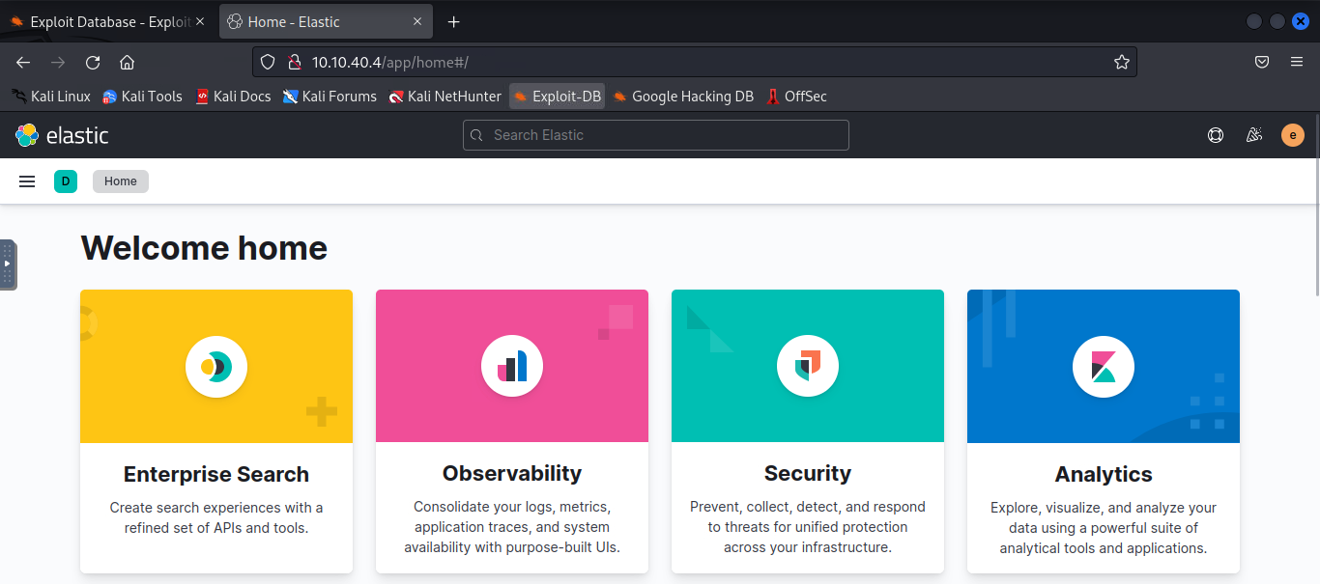

Discover

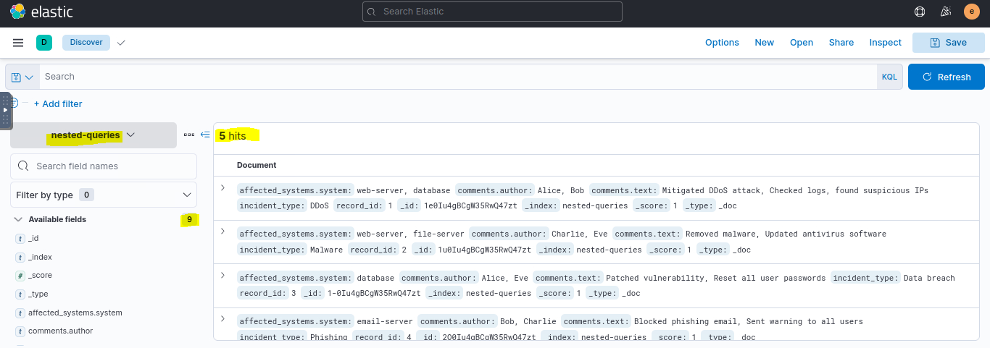

Query

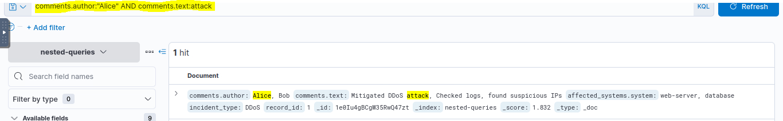

Incidents from jan 1 2022 till now. 1000 Hits

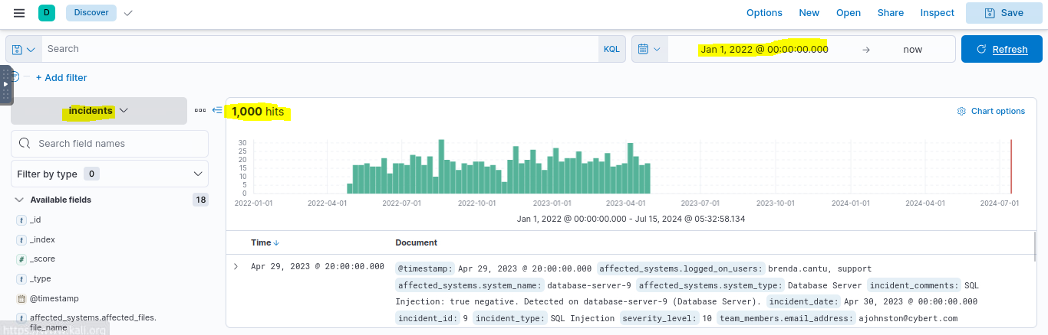

Affected file name hits

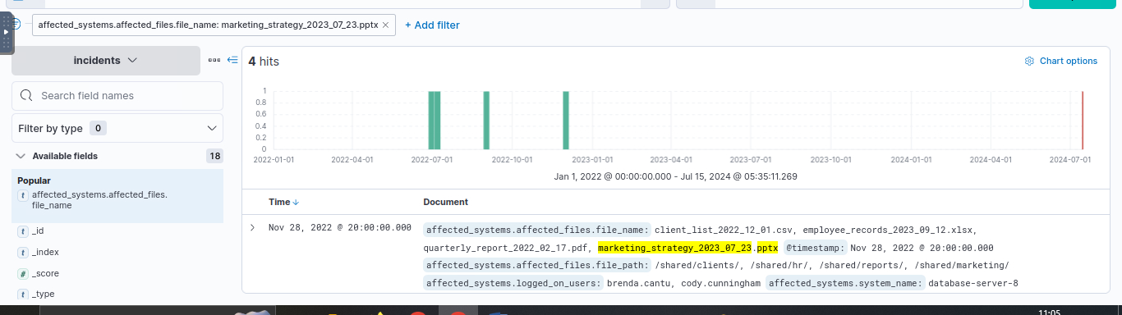

File Server

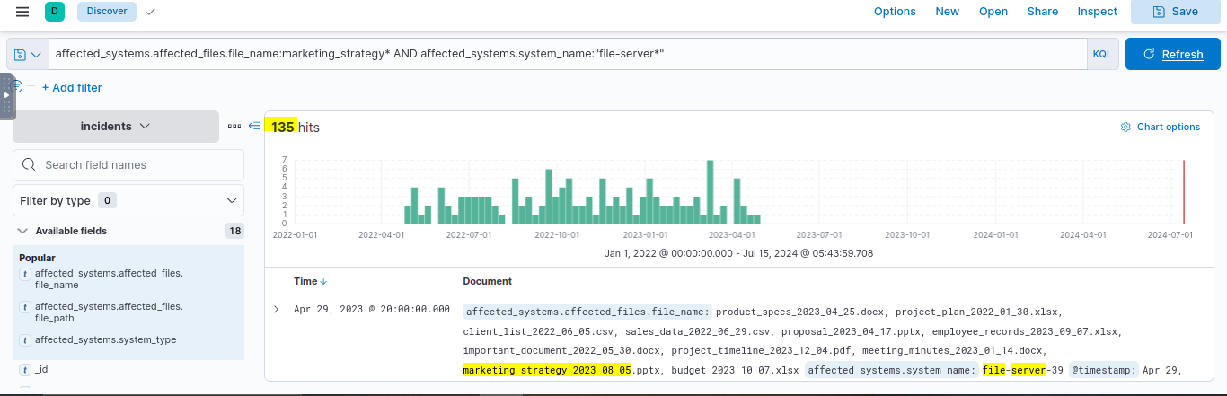

True positive admin login

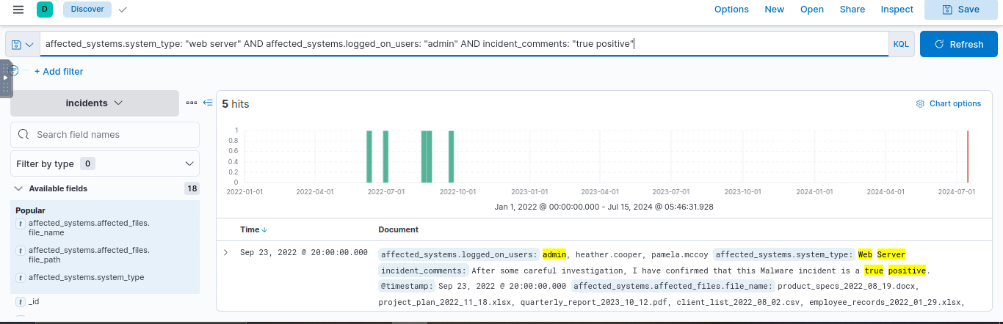

**Ranges**

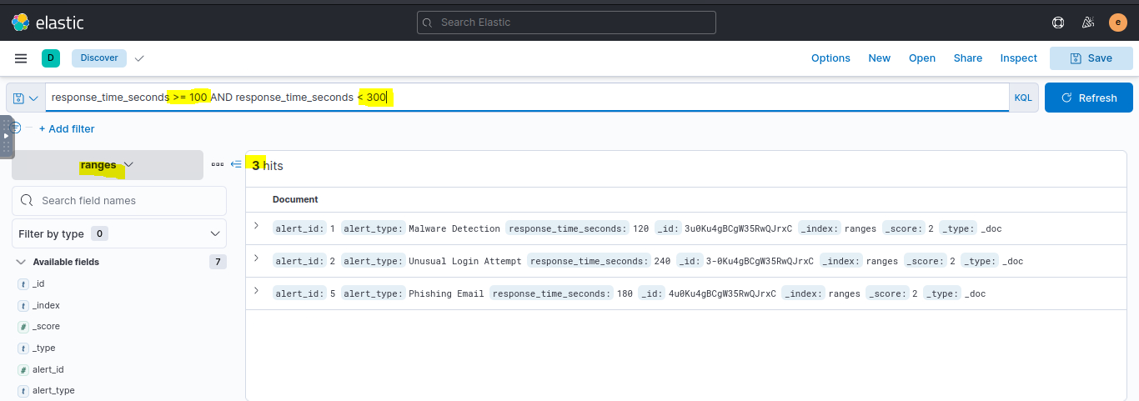

Data leak with severity

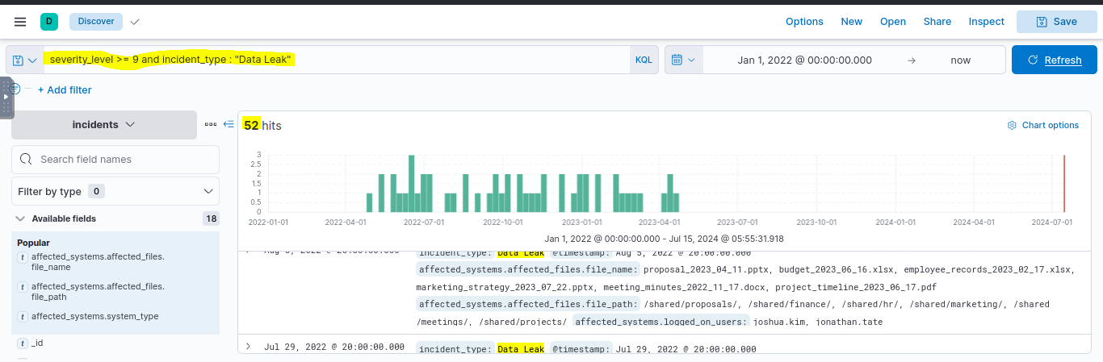

Time stamp before December 1

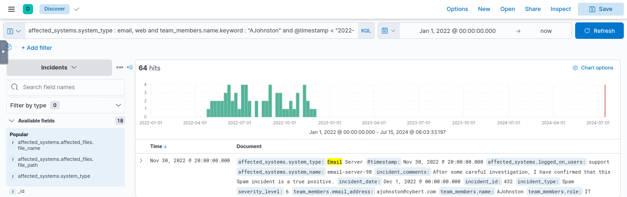

incident_id > 1 and incident_id <= 500 and incident_comments : "Data Leak" and affected_systems.system_name : "file-server-65"

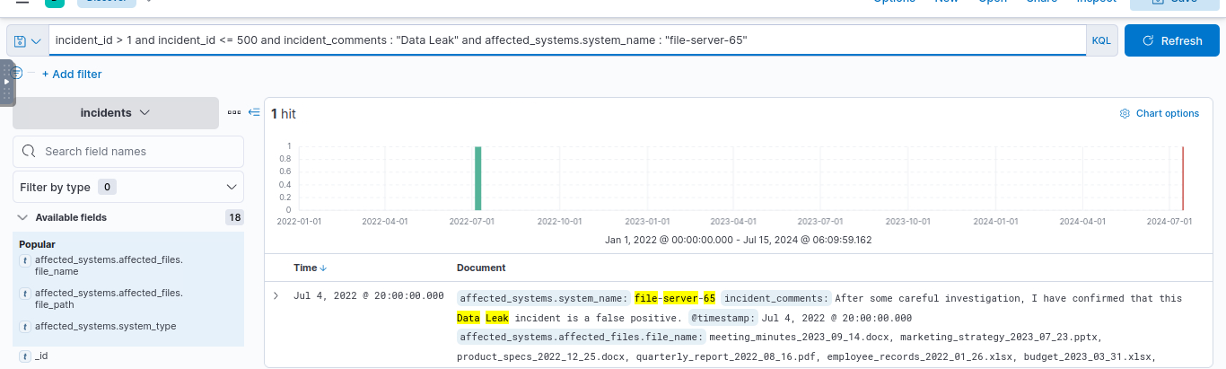

Lucene – fuzzy search

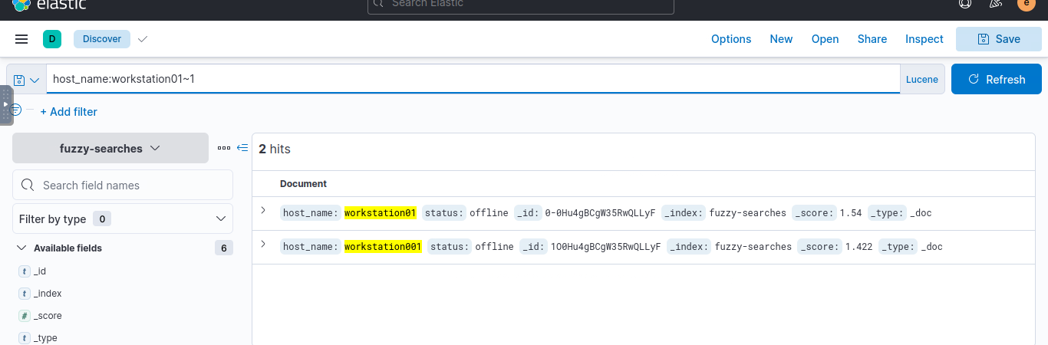

Proximity searches

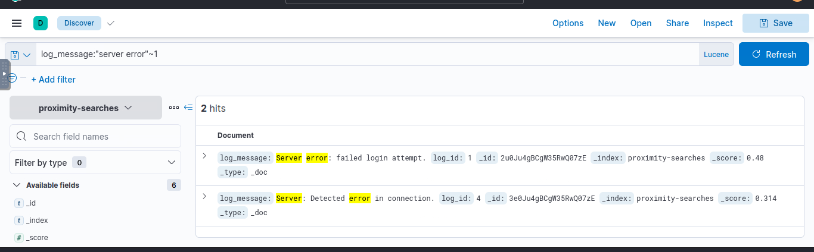

Regular expressions: all event types

